Summer 2025
I am writing to you on behalf of The Next Step Trust; a registered charity supporting adults with complex health needs, learning disabilities and autism across Calderdale. Founded in 2006 by parents who found there were limited options for their sons and daughters after high school, Next Step now operates three day services in the heart of Halifax and a respite provision in Southowram.
At Next Step, we’ve always believed that meaningful goals are worth striving for. One of our earliest aspirations was to build our own Hydrotherapy Pool— a goal we proudly achieved during the challenges of the COVID pandemic, no mean feat! It wasn’t easy, but with persistence and purpose, we made it happen. Now, with that milestone behind us, we’re ready to set our sights on achieving our next dream.
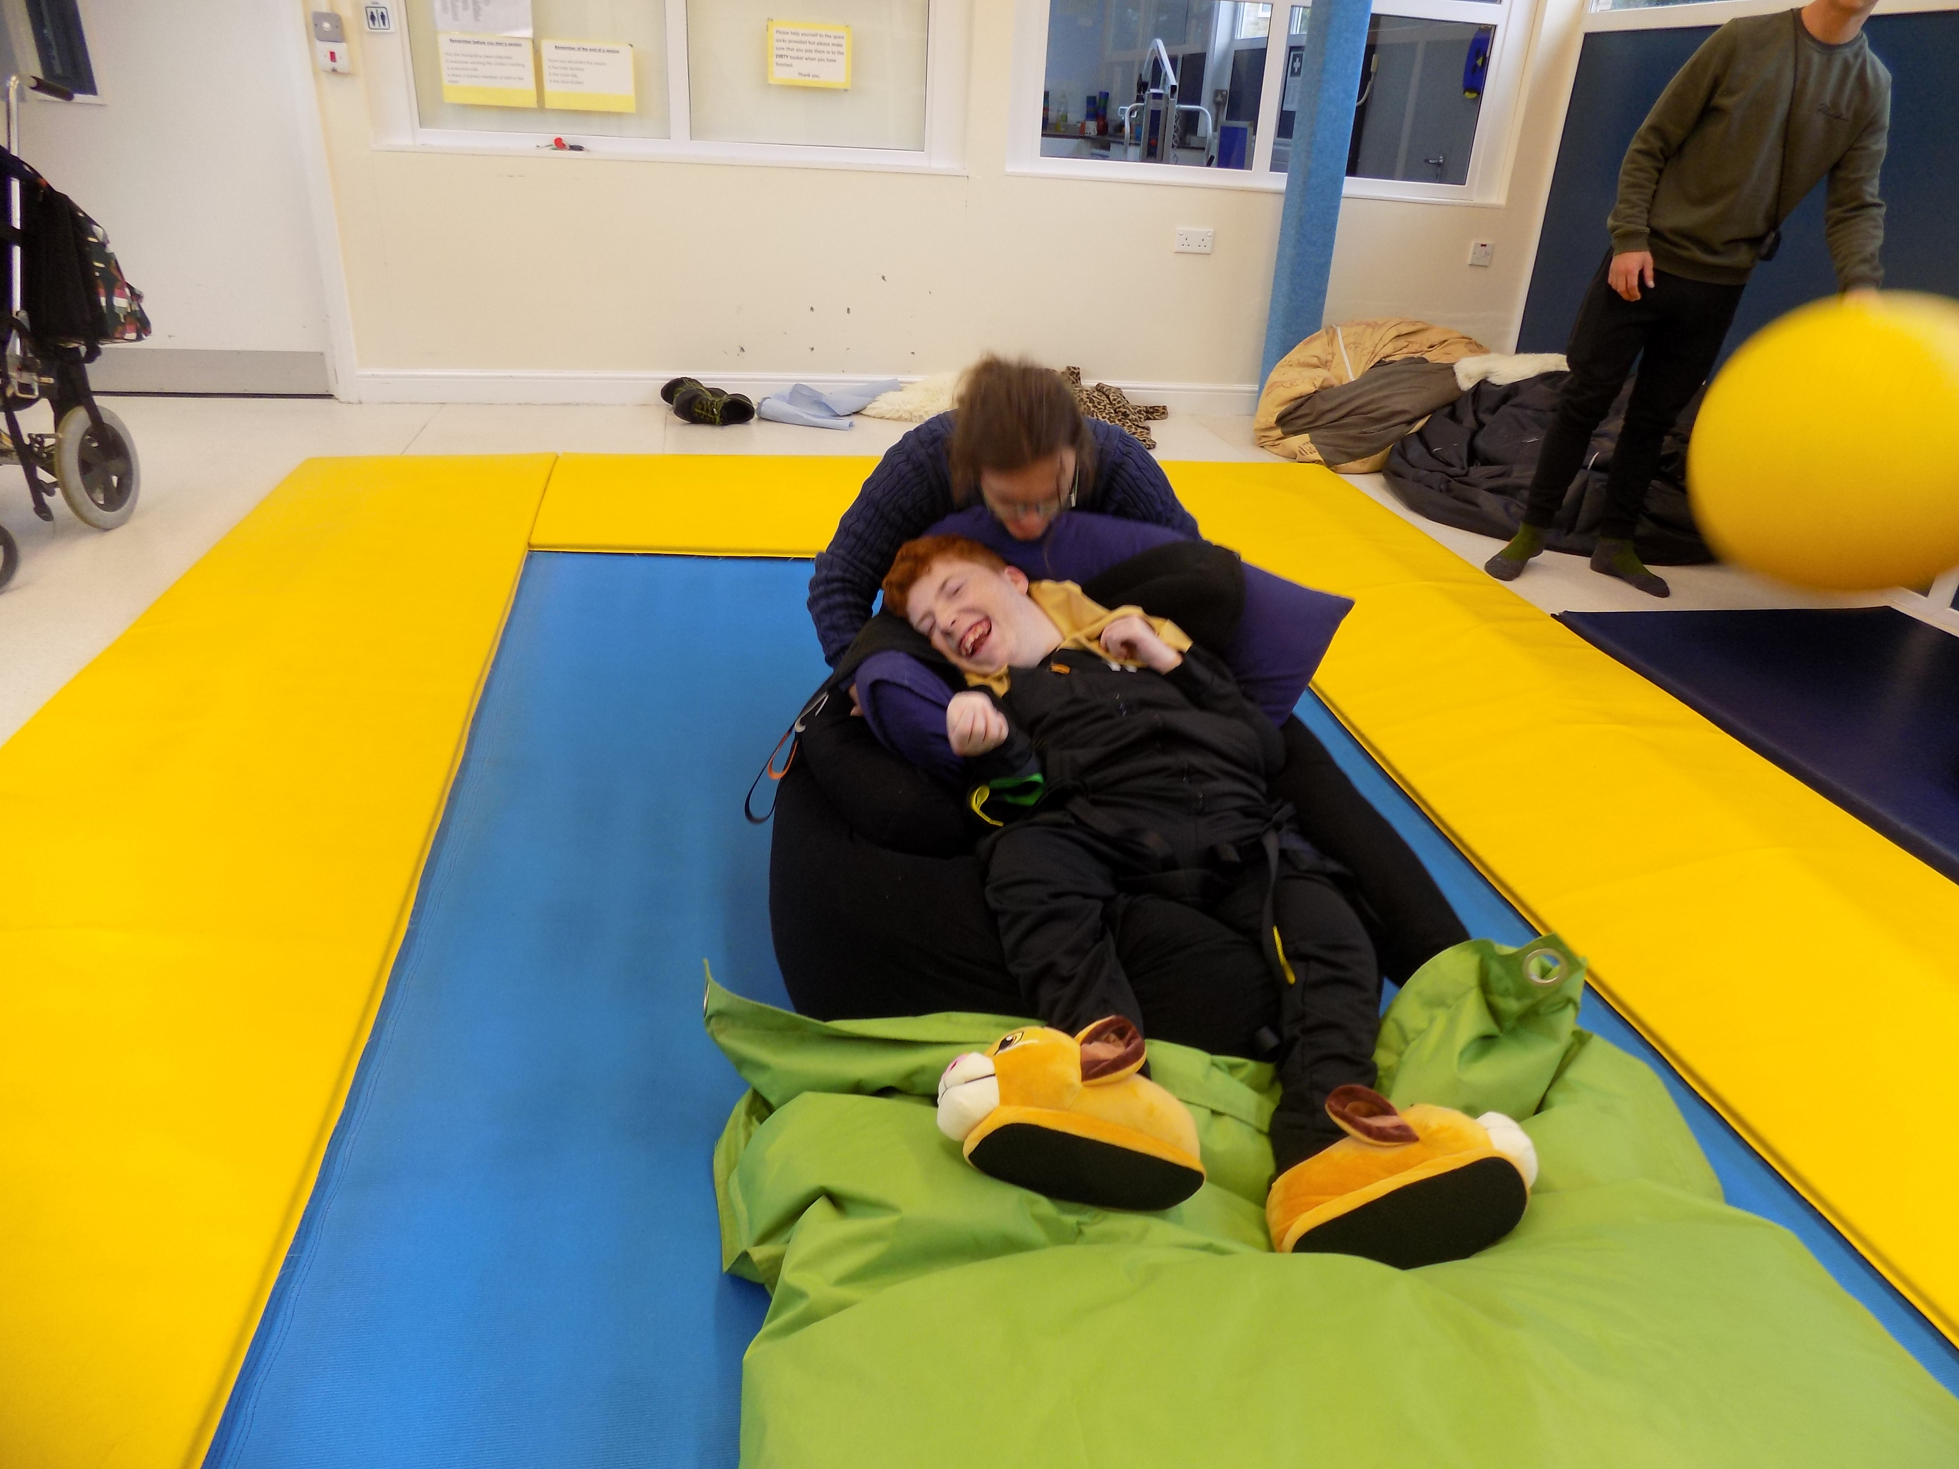I am writing to invite you to support two important initiatives that are close to our hearts and have a profound impact on the individuals that we support; a Rebound Facility and a Garden of Memories. We are currently seeking funding to bring these projects to life, each with its own unique purpose and meaningful impact on the lives of those we support.
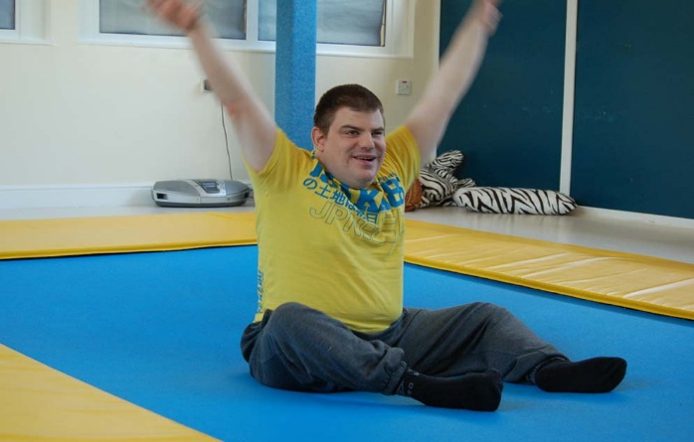
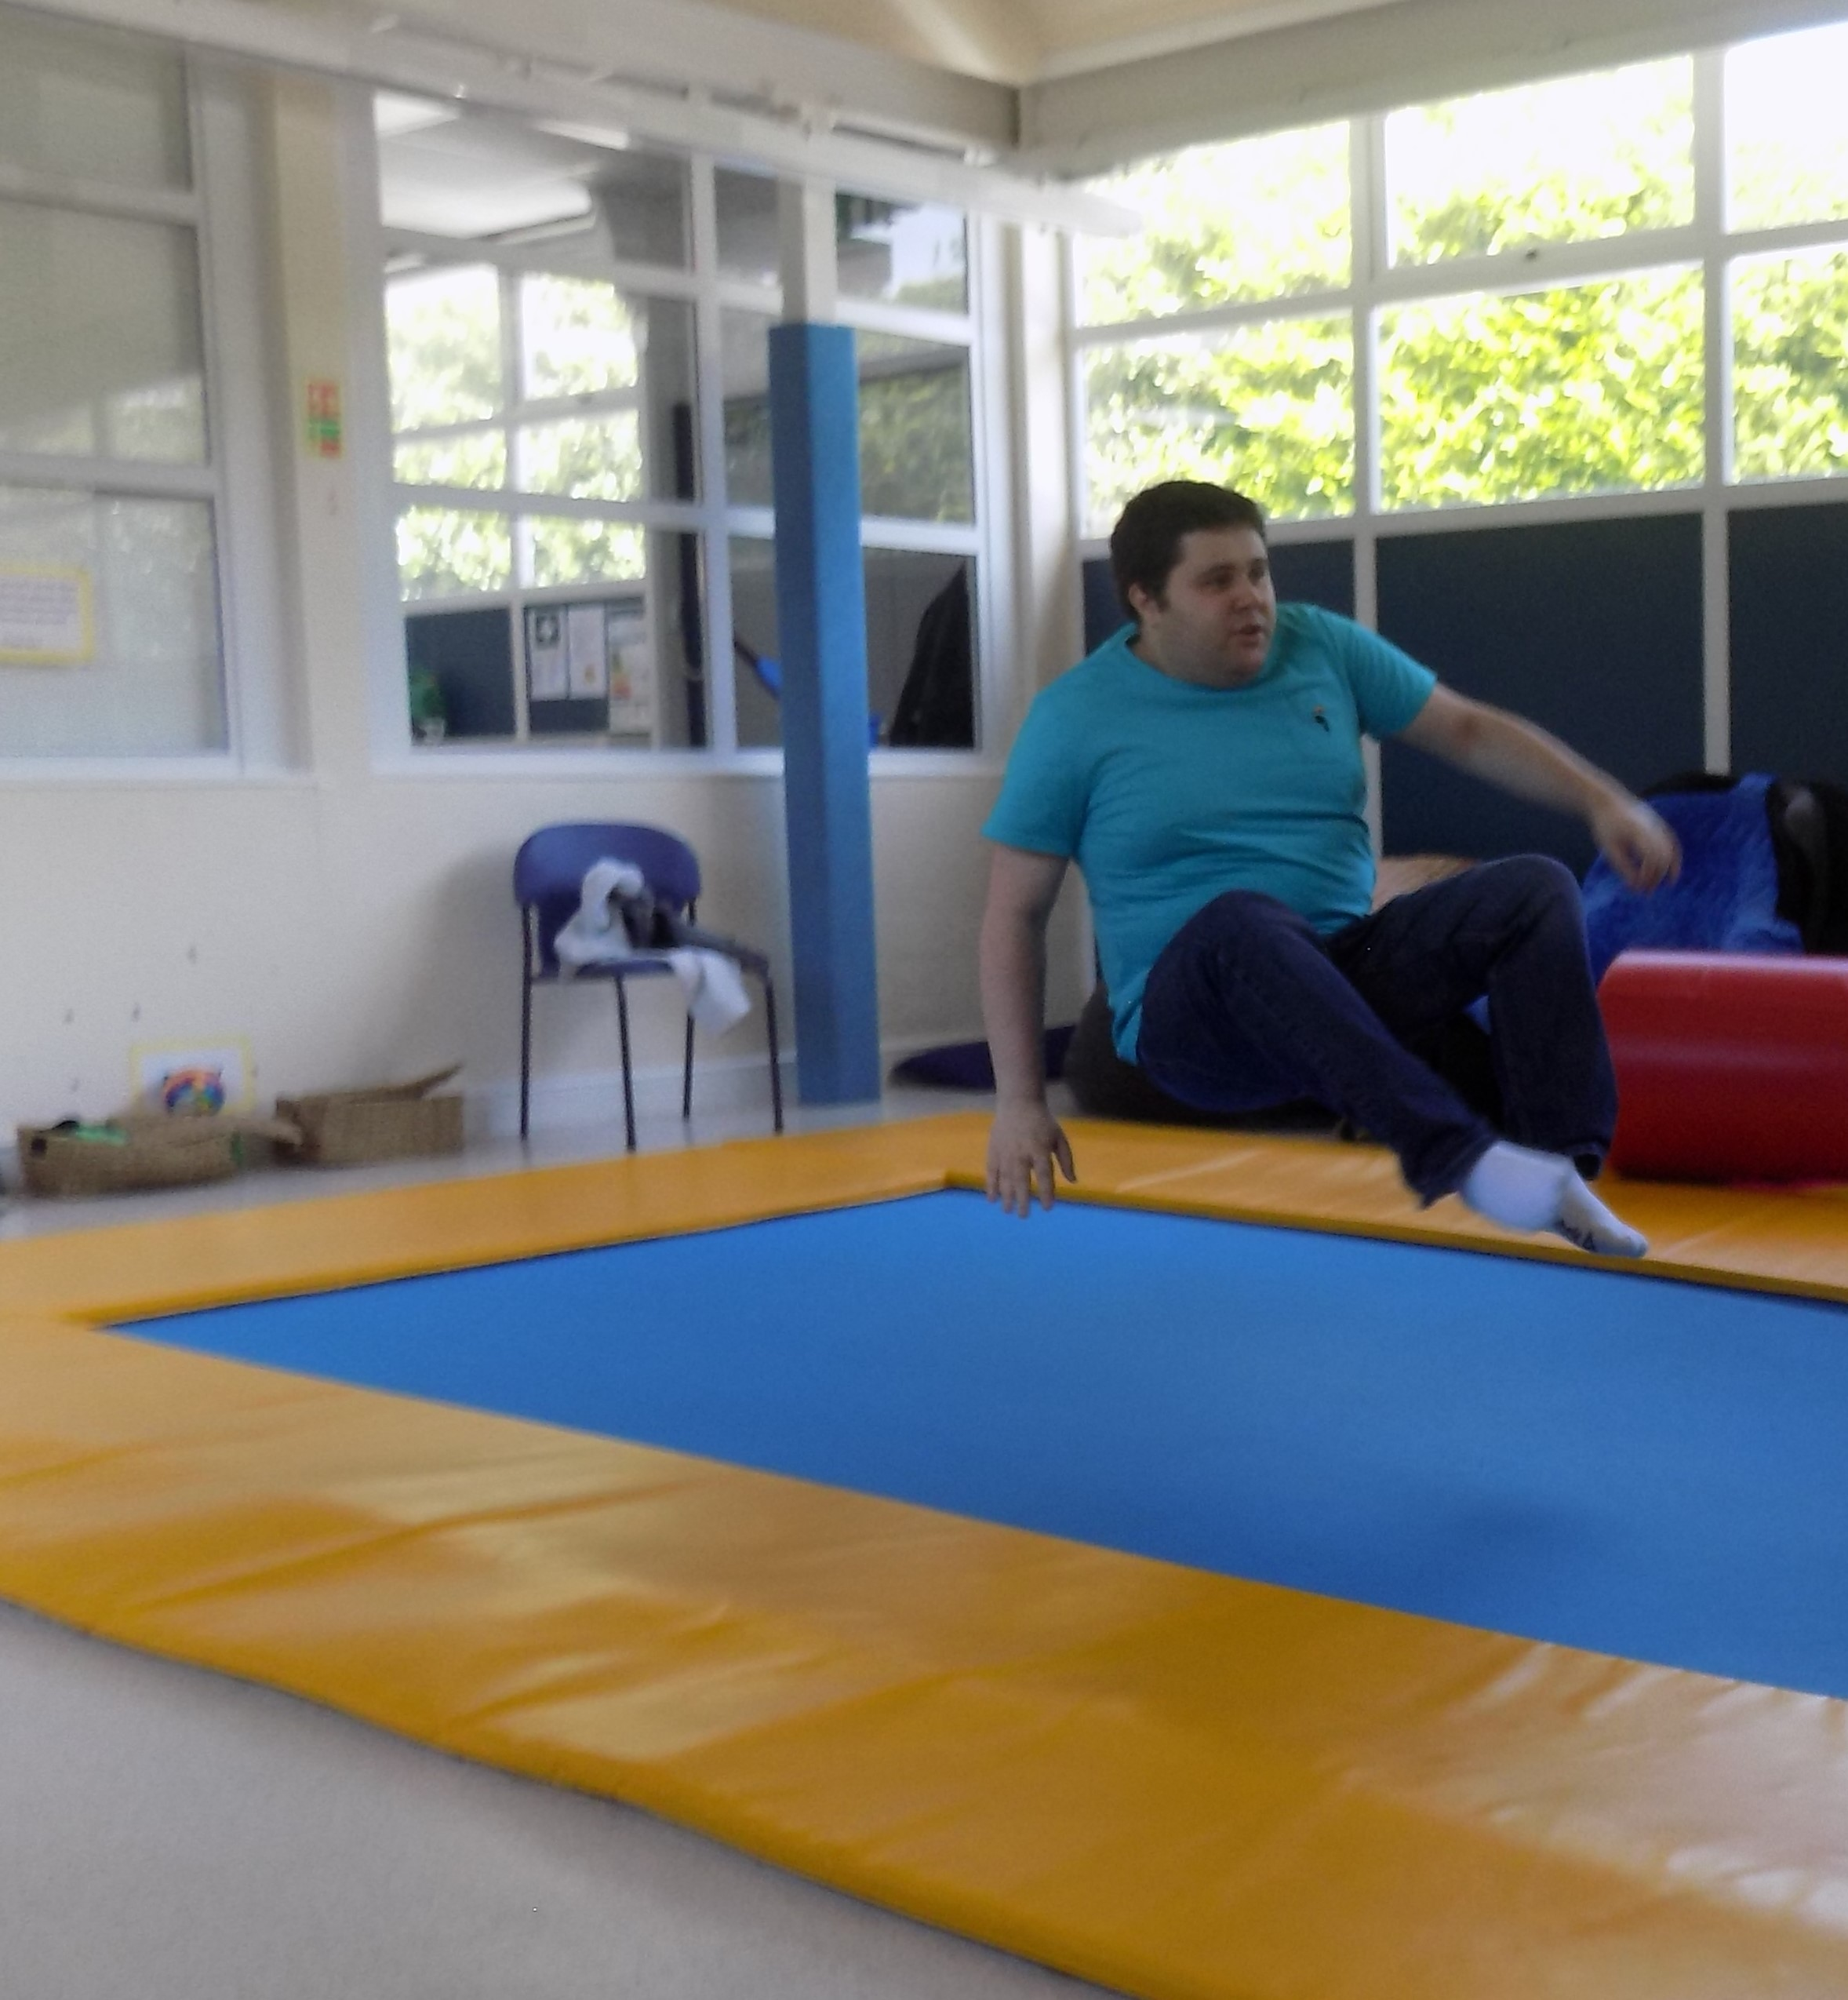The Rebound Facility will offer specialised therapy through the use of rebound trampolines in providing therapeutic exercise offering multiple benefits for those that we support. Rebound Therapy helps improve flexibility, coordination, and core stability, while also enhancing balance, posture, and muscle tone. It promotes independence, builds confidence with movement, and also encourages communication and concentration skills. Additionally, it offers a fun and engaging way to improve cardiovascular health, increase stamina, and alleviate tension. It can also have additional physiological benefits, such as stimulating the digestive system and improving bowel function. This facility will create a space for individuals to achieve greater physical and emotional well-being, while fostering a sense of achievement and joy through movement.

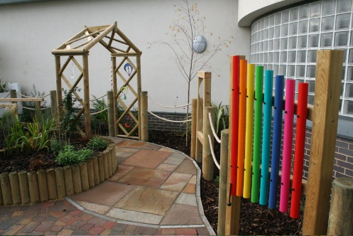
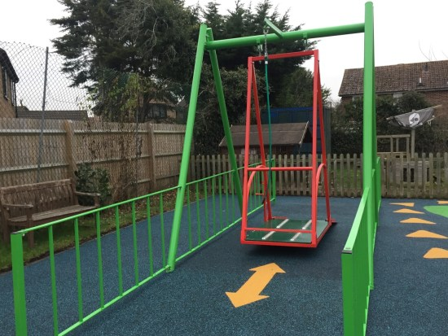
The Garden of Memories is an equally important project, designed to offer a peaceful, sensory-rich outdoor space for reflection and connection. This garden will not only serve as a tranquil environment for our Next Steppers but will also provide a special place to honour those that we have had to say goodbye to. It will feature a swing, which will offer a calming, therapeutic and fun experience for those who use it, helping to foster relaxation and emotional well-being. The Garden of Memories will be a space for healing, remembrance, and serenity, providing comfort to those who need it most.

Here’s how you can support us
- Donate a prize for our auction & raffle, no prize is too small or too large!
- Make a donation;
  - On our local giving page, https://localgiving.org/nextsteptrust
  - Directly to NST, please contact Megan on 01422 330938 for further information
  - Post a cheque to our head office, address detailed below
- Offer your time and expertise! We will be looking for skilled professionals such as builders, electricians, horticulturists, and more. If you believe you can assist us in any of these areas, please do get in touch.
For context and pending final quotes from contractors, we’re aiming to raise around £60,000 for the Rebound Facility and £25,000 for the Garden of Memories.
If you would like to visit us please do get in touch, we would love to have you.
A huge thank you for considering this opportunity to invest in something that would make a huge difference to our Next Steppers.

With thanks,

Verity Cleary
Deputy Operations Manager

